TMA Supplier Packaging Design Approval Form

Supplier:
TMA Part Number/Description:
Supplier Contact:
Supplier Phone Number:
Supplier Email:

Inner Packaging

Inner pack boxes should consist of a corrugated carton measuring 12” L x 7” W x 5” H

All inner pack boxes must have a 3” x 3” white label placed on one end of the box. The label must contain the following information:

Supplier Name Release Number
Part number (with Barcode) Revision Level
Quantity (with Barcode)

Inner pack boxes not to exceed 35 lbs.

Outer Packaging

Outer Packaging should consist of a corrugated carton 30” W x 36” L on a pallet with the same measurement.
Pallet with carton should not exceed 34” High.
Outer carton should have a removable lid.
Carton should be poly strap banded to pallet.
Pallet should be stretch wrapped.

All outer pack cartons must have 4” x 6” white labels on 2 sides of the carton (front and back). The label must contain the following information:

Supplier PO Number Ship Date
Part Number (With Barcode) Revision Level Weight
Description Release Number
Quantity (With Barcode) Packing Slip #

Packaging Configuration

Outer Pack Label

4” x 6”

Inner Pack Configuration
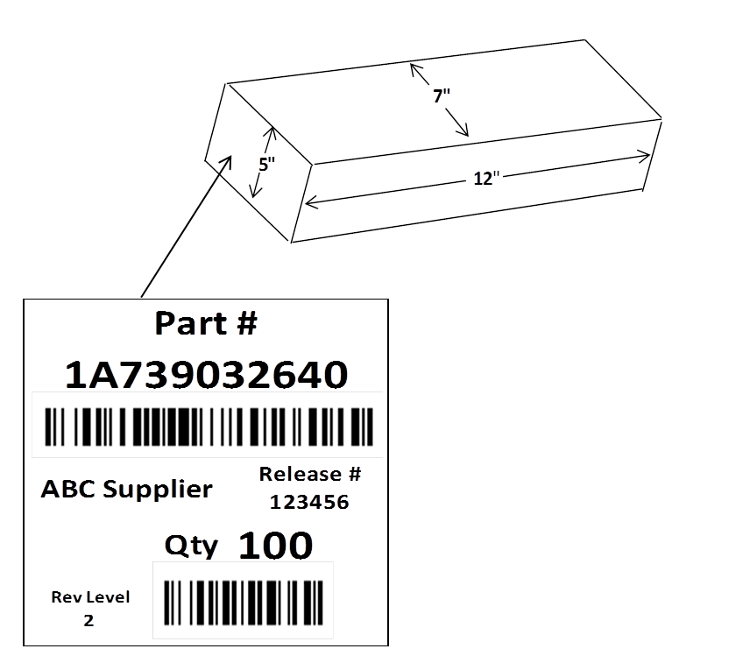
3” x 3”

Sample Pallet

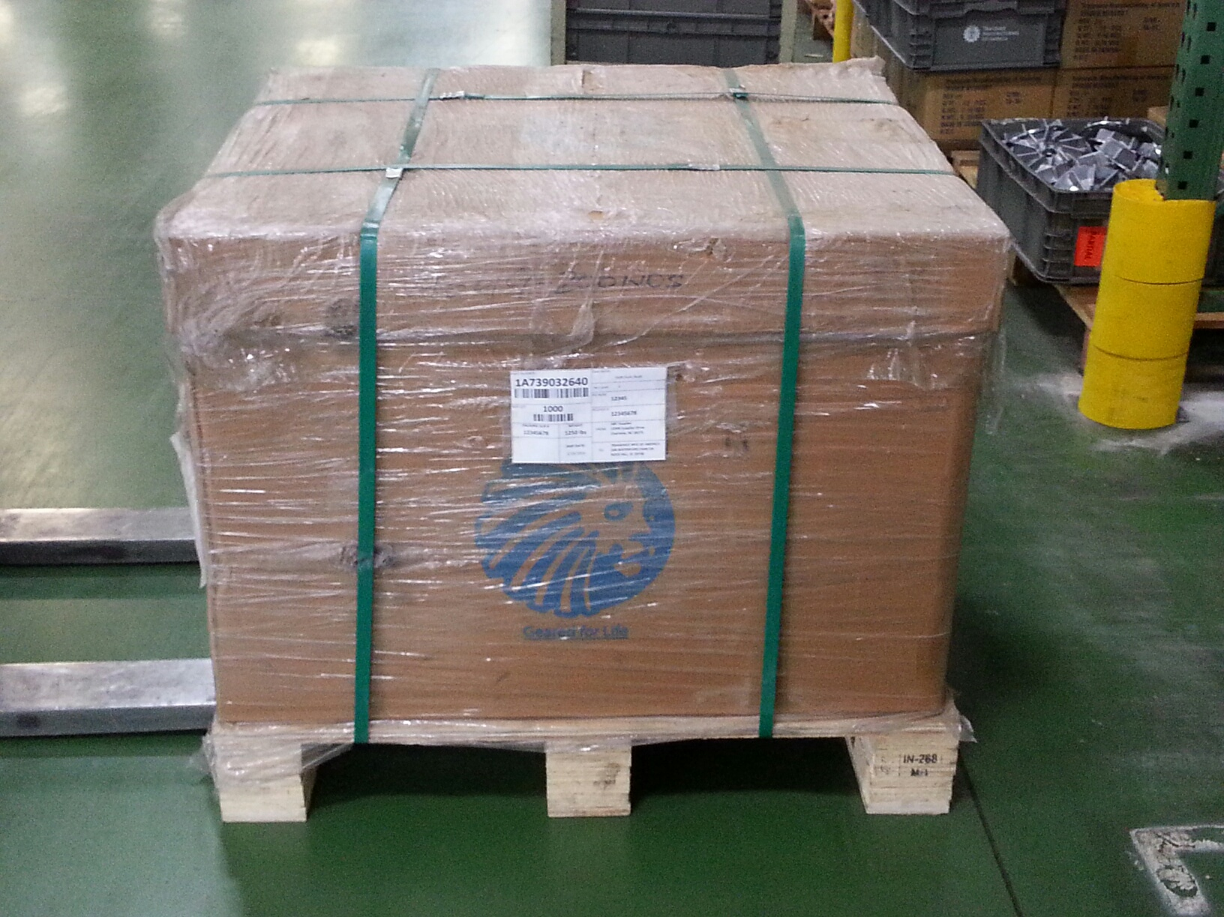

Pallet Configuration

Bulk Packaging

Bulk Packaging should consist of a corrugated carton measuring 30” W x 36” to 42” L on a pallet with the same measurement.

Pallet with carton should not exceed 34” High.

Bulk Packaging must have 4” x 6” white labels as described above.

Multiple Parts in One Carton

Cartons containing multiple part numbers must be clearly marked as: “Mixed Carton”

Mixed cartons must have white labels listing all part numbers, descriptions and quantities in the carton. This label must be on 2 sides of the carton.

Please provide steps for Inner Packaging perseveration. Please include pictures and description.

Step: 1 Step: 2 For Step 2, Check All That Apply:

RP
Type: ______________

Protective Netting

Protective Sleeve

VCI Paper

Other:____________

(Insert Photo of Part with
Protective Packaging; netting,
bag, protective sleeve, etc.)

(Insert Photo of Part only)

Bulk Packaging should consist of a corrugated box measuring 30” W x 36” to 42” L on a pallet with the same measurement.

P

Description: Description:
_____________________ _____________________
_____________________ _____________________
_____________________ _____________________
_____________________ _____________________
_____________________ _____________________

For step 3,
Step: 3 Check All That Apply Step: 4 For step 4, Label Must Contain:

(Insert Photo of finished Inner Pack Box with Label)

Supplier
Part Number
Quantity
Release Number
Lot Date
Revision Level

Desiccant
Bag/Pack

VCI Bag

VCI Paper

Other_______

(Insert Photo of Part(s)
within Inner Pack Box)

Box Dimensions

Length 12”
Width 7”
Height 5”

Weight can not exceed 35lbs

Description: Description:
_____________________ _______________________
_____________________ _______________________
_____________________ _______________________
_____________________ _______________________
_____________________ _______________________

Please provide steps for Outer Packaging preservation. Please include pictures and description.

Step: 5 Check All That Apply for step 5
Desiccant Bag/Pack

VCI Bag

VCI Paper

(Insert Photo of the contents
inside shipping box)

Description: ______________________
______________________
______________________
______________________
______________________

Step: 6 For step 6, labels must contain:

Supplier Part Number
Part Description
Quantity
PO Number
Lot Date
Release Number
Packing List Number
Revision Level
Ship Date
Weight

MAX Pallet
Height: 34” (0.863m)
Width: 48” (1.22m)
Length: 48” (1.22m)

(Insert Photo of
Container/Box)

NOTE:

MAX Pallet

Height: 34” (863mm)
Width: 30” (762mm)
Length: 42” (1066mm)

Confirm Dimension
Height: ___________
Width: ___________
Length: ___________

Description:
______________________
______________________
__________________________
__________________________
______________________

Additional information for preservation to protect the material during shipment. (Not all parts are applicable)

As a Supplier you are still responsible for the protection and preservation of all material shipped to TMA.

Suppliers agreed to the statement above. Please sign here and Date DATE

TMA Material Flow Coordinator Signature DATE

TMA Buyer/Planner Signature DATE

TMA Supplier Quality Engineer DATE

TMA Logistics Manager Signature DATE

